CURRICULUM VITAE
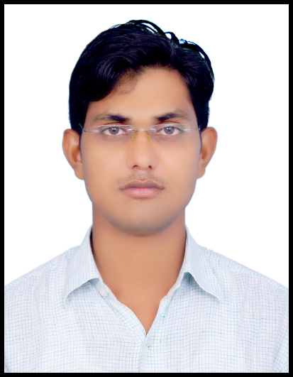
Name: - Sarfraz Ahmad
Contact No. :-09891208570

Email-sarfraz.iu@gmail.com

CAREER OBJECTIVE

To pursue a career as an electrical engineer within automation field which provides me job satisfaction, self development and help me achieve personal as well as organizational goals.

PROFENSSIONAL EXPERIENCE

Organization : Industrial IT Solutions Pvt. Ltd.
(Authorized System House of ABB)
Designation : Electrical Engineer

Duration : 2014 to till now

EXECUTIVE SUMMARY

Dedicated electrical engineer with more than 3 years’ of experience in the field of Electrical and Automation and managing all aspects of projects’ life cycle, offering the following core competencies:

      - Well-round engineering experience – Design, develops, test and supervise the manufacturing and installation of electrical equipment, Cable calculation, Load calculation.
      - Preparing layouts & SLD’s for the project as per the process and material flow needs.
      - Preparing BOMs of specific panel as per requirement.
      - Hands on experience of AC drive ACS850, ACS550 ,ACS880 & ACS580
      - Hardware knowledge and selection of AC Drives.
      - Hardware knowledge and selection of DC Drives.
      - Hardware knowledge and selection of soft-starter.
      - Hardware knowledge and selection of FCMA.
      - Retrofit Job of electrical PCC, MCC & Drives panel.
      - Busbar designing for MCC, PCC & PMCC Panel.
      - JB (Junction box) & DB (Distribution box) calculation from Plant layout.
      - Erection, commissioning and trouble shooting of LT Panels.
      - Basic knowledge HT Panels.(VCB & Transformer)
      - Cost estimation of electrical package for new project.
      - Able to run engineering projects from inception to success.

      - Accuracy, responsibility and accountability – Excellent attention to details and well organized.

CORE KNOWLEDGE AND FUNCTIONAL SKILL AREAS

- Panel Designing
- Panel Manufacturing
- Industrial AC motors
- Industrial DC motors
- Industrial AC Drives
- Industrial DC Drive
- Soft-Starter digital type
- Soft-Starter (FCMA type)
- Erection and Commissioning
- Auto CAD

IT EXPOSER

Working knowledge of Window’7 (MS Power Point, MS Word, MS Excel etc).

COMPANY PROFILE

Industrial IT Solutions Pvt. Ltd. is established in the year 2000 by professionals having vast experience in the field of Instrumentation, Controls and Plant Electricals.
The company has been providing solutions throughout the plant, providing customized solutions as per the process requirements. Industrial IT Solutions Pvt. Ltd. is an Authorized System House for ABB for their Automation, Electrical and Instrumentation products.
Its work in sugar plant, power plant, paper mill & Steel plant Etc.

KEY PROJECTS HANDLED IN WORK OFFICE

- Selection of AC & DC drives as per Application.
- Selection of Switchgear as per application.
- Design & Testing of AC Drives panel for various fan application like Induced draft fan (ID Fan), Force draft fan (FD Fan), Primary Air Fan (PA Fan), & Secondary Air Fan (SA Fan).
- Design & Testing of AC Drives panel for various Pump application like Boiler feed pump (BFW Pump), Spray Pump.
- Design & Testing of DC Drives panel for various Mill applications like ETR &DTR (4Hi Mill), Sugar Mill, Rubber mixing machine & Classifier for cement industries.
- Design of Direct on line starter & Star-Delta Starter boxes for WTP.
- Design & Testing of PCC, PMCC & MCC LT Panel for various Industries.
- Busbar designing for LT Panels
- Design & Testing of Auto Power Factor Correction(APFC) Panel
- Preparing BOM & Design of PMCC Panel for M/s.Tahal Group.
- Power cable calculation of Motor for M/s.Tahal Group.
- JB & DB counting by plant layout M/s.Tahal Group.

KEY PROJECTS HANDLED ON THE SITE

- Installation & Commissioning of AC Drive (Single) in M/s. Shabad Sugar mill, Application:-Fans.
- Installation & Commissioning of AC Drive (Single) in M/s. Star Wire., Application:-BFW Pump.
- Installation & Commissioning of AC Drive (Single) In M/s. Magna Rico Power.,
Application:-Performance Testing Machine.
- Installation & commissioning DC Drive M/s. Prime India.
- Retrofitting & Commissioning AC Drive in M/s. JSL Odisha,
- Installation & Commissioning of MCC Panel in M/s.Rungta Mines Odisha, Application:-Kiln.
- Installation & Commissioning of PCC Panel in M/s. Rungta Mines Odisha, Application:-Kiln.
- Cable lying in plant.

ACADEMIC QUALIFICATIONS

Bachelor of Technology in Electronics & Communication Engineering from Integral University
Passed 12th (UP Board) and 10th from H.H.S School (U.P)

- Project: - production and utilization of energy from busy road(energy conservation )

SELECT PROJECTS AND SEMINAR

Description:- This project deals with an advanced production of energy from busy road .
The main objective of this project is to utilize of wasted energy from busy road.

- Seminar :- On plasma antenna

Description:- In this seminar I have to collect all the relevant details about plasma antenna used and represented it towards my HOD and faculty members. I have to clear all queries of teachers and students about plasma.

INTERNSHIPS/FULL TIME WORK EXPERIENCE

- Study of optical-electronics in Research Designs and Standard Organization.
(RDSO Lucknow).

EXTRA CURRICULAR ACHIEVEMENTS

- Batch coordinator during my training period in R.D.S.O, Lucknow.

OTHER INFORMATION/ INTERESTS

- Attended national workshop on industrial automation at Integral University, Lucknow.
- Attended seminar on 3G at Integral University, Lucknow.

PERSONAL DETAILS

Name | Sarfraz Ahmad
Date Of Birth | 15/08/1989
Marital Status | Single
Gender | Male
Nationality | Indian
Passport No. | P4958995
Languages Known | Hindi, English & Urdu
Local Address | Badrpur Border Near kasana complex
Permanent Address | Post-Kopaganj, distt Mau,U.P –Pin Code-275305

DECLARATION

(I hereby declare that the information furnished above is true and best of my knowledge and also completed my B. Tech and have the mark sheet of all the semester)

Sarfraz Ahmad

